Wanniassa Logo Wanniassa School

Junior Campus***Partners in Learning***

Sternberg Crescent Wanniassa Phone: 6205 7566

Website: [www.wans.act.edu.au](http://www.wans.act.edu.au/" \o "Wanniassa School Website) Email: [info@wans.act.edu.au](mailto:info@wans.act.edu.au) Facebook icon Wanniassa P-10 School

Information Update No: 1 Wednesday 11th Mar 2015

# Our Value this fortnight - Doing Your Best (Sportsmanship)

| Dates to Remember | |
| --- | --- |
| Thursday 12 March | Swimming Carnival Years 2 - 6 |
| Friday 13 March | Blue Unit Assembly 11.30am |
| Friday 27 March | Green Unit Assembly 11.30am |
| Friday 3 – Monday 6 April | Easter Long Weekend |
| Thursday 9 April | JC Athletics Carnival |
| Friday 10 April | Last Day Term 1 |
| Monday 27 April | ACT Public Sector Holiday (in lieu of ANZAC Day) incl. Public School Students |
| Tuesday 28 April | First Day Term 2 |
| Thursday 14May | Kinder Health Screening |

| Notes Sent Home | |
| --- | --- |
| School Requisite/Internet Reminder | Selected |
| Canteen Menu | Youngest |
| Special Lunch Order | All Students |
| Swimming Carnival Re-Scheduled | Years 2 - 6 |
| Rugby League 7’s | Selected |

# 2015 Term Dates

Term 1 Monday 2 February - Friday 10 April

Term 2 Tuesday 28 April - Friday 3 July

Term 3 Monday 20 July - Friday 25 September

Term 4 Monday 12 October - Friday 18 December

**Please note: Students resume Term 2 on Tuesday 28 April (not Monday 27 April as previously stated)**

# Student Representative Council

SRC representatives are voted in by the other students in their class. During SRC meetings, students learn how meetings run, talk about fundraising ideas and discuss how raised money could benefit the school and other charity groups. The SRC is an opportunity for students in the school to take on a leadership role. It allows SRC reps to be involved in communicating student’s ideas and concerns to others within the school community.

We would like to extend our congratulations in welcoming our new SRC for Semester 1 (please note Year 6 councilors serve for the entire year).

# SRC Representatives for Semester 1, 2015

KG Maddison Edney and Shaun Still KG/J Lilly Williams and Dexter Wallace

1C Tahlia Oshyer and Jesse Williamson 1E Addison Gemmell and Hunter Wilcox

2/3B Sally Wickson and Jason Williams 2/3H Takiesha Bowen and Mark Bodrozic

2/3JB Stephannie Ahadizad and Blake Piromalli 4W Shayla Young and Kai Elphick

4/5E Charleigh Byrne and Sharman Walia 5P Youssra Al Sweity and Spencer Kinniburgh

6B Keely Robinson, Brave Thomas, Riley Davis and Oliver McLauchlan

# Sports House Captains and Vice Captains

Congratulations to the following students for being elected as new leaders for 2015.

**Gingera** **Captains:** Heidi Byrne and Zander Griffin **Vice Captains:** Maddison Perrett and Liam Thompson

**Billy Billy Captains:** Brave Thomas and Oliver McLauchlan **Vice Captains:** Chelsea Johnstone and Riley Montagner

**Tennent Captains:** Rachel Kitchener and Ryan Oshyer **Vice Captains:** Isabella Morelos and Victor Uelese

**Namadgi Captains:** Kira Scanes and Riley Davis **Vice Captains:** Chloe Baker and Sebastian Woods

# School Psychologist

My Name is Amit Pearce and I have started as the School Psychologist at Wanniassa Junior Campus for 2015. Many of you would have known Rob Walls as the previous School Psychologist, who I have taken over from, as he retired at the end of last year.

I have been working in the Education and Training Directorate for the past 3-years as a School Psychologist working at various schools such as Mawson Primary, Taylor Primary and Namadgi School. I have been a Psychologist for the past 11-years and had previously been working within the ACT Mental Health system for 9-years working with adults and later within various areas of the Child and Adolescent Mental Health Service (CAMHS) in various roles from a senior clinician to team leader of the Adolescent Day Unit called the Cottage.

I hold a Masters Degree in Clinical Psychology and hold a specialist endorsement as a Clinical Psychologist with AHPRA (Australian Health Professional Regulatory Association) as well as APS (Australian Psychological Society).

I am excited to be a part of the dedicated, innovative and caring Wanniassa School community and look forward to meeting many of you and supporting our school community – the students, parents and staff.  Please feel free to come in and introduce yourselves when time permits. I will be at Wanniassa Junior Campus every Tuesday and Thursday.

# Bookpack/Internet Payments

Just a reminder, Friday 20th February was the due date for payment of our school requisite package ie: bookpack and internet access. Thank you to those who have already paid in full.

If paying by instalments, your next payment would be appreciated as soon as possible.

# Wanniassa School Hats ** No Hat No Play**

Students are required to wear a hat during outdoor class activities and during recess and lunch.

Due to health regulations, spare hats cannot be issued. School hats are $7 each.

# Kindergarten Health Screening

The Women Youth and Children, Community Health Programs (WYCCHP) offers a health check for all Kindergarten children in the ACT. This health check is designed to identify health issues early, to allow for appropriate referral and intervention. The process of the health check requires completion of a questionnaire which has been distributed. Please return this to your child’s teacher as soon as possible. The health check will take place at school on Thursday 14th May, 2015.

# Mother’s Day/Father’s Day Stall Volunteers Needed on JC

The P&C is looking for a volunteer or two to:

•         To liaise with the school to make arrangements to hold stall;

•         Advertise for donations •         Prepare & price gifts •         Run the stall on the day

Note: The P & C have pre-purchased some gifts from a supplier while on sale last year

•         Mother’s Day is Sunday 10 May •        Father’s Day is Sunday 6 September

If you are able to assist please contact Lynette Sanchez on 0409 044 251 or email [lynettesanchez@grapevine.net.au](mailto:lynettesanchez@grapevine.net.au)

# Canteen News

The canteen is open four days a week, Tuesday - Friday from 9am, with over the counter sales during recess 11 - 11.30am and lunch 1.10pm - 1.30pm.

Thank you for your ongoing support and commitment to keeping our canteen open. Please continue to donate ingredients and groceries. Parents, grandparents or friends from the community are always welcome to assist in the canteen. If you have time to spare occasionally, please drop in or call Jody on 6231 2717.

Also, be reminded that the canteen is closed on Mondays.

# **Canberra Physical Culture Club**

Physie is for girls and ladies of all ages. Exercises and dance routines are all choreographed to music and are designed to enhance flexibility, strength, agility, poise and deportment.

Children especially benefit by improving their stamina, concentration, co-ordination and balance. We are an incorporated club and we try to keep costs low and offer 2 free lessons.

New members are always welcome to come along and see if they would like to join our club.

Classes are held here at Wanniassa School Junior Campus. Please call Maree 0411600658 or visit [www.canberraphysicalculture.com](http://www.canberraphysicalculture.com)

# New NDIS Grants Now Available in the ACT

The ACT Government has just announced new grants to help prepare people for the National Disability Insurance Scheme (NDIS). **Go to** [**www.act.gov.au/ndis**](http://www.act.gov.au/ndis) **to find out more.**

There are grants of up to $1,000 for people with disability, their families and carers, as well as grants of up to $10,000 for organisations.

The grants will enable **people with disability, their families and other unpaid carers** to participate in conferences, seminars, learning or training events related to the NDIS. Or engage a facilitator to help develop or work towards life goals and plan for the future.

The grants will enable **organisations** to seek sponsorship from the ACT Government towards costs associated with hosting conferences, seminars and other events about the NDIS in the ACT.

For more information about the grants, and to apply, go to: [www.act.gov.au/ndis](http://www.act.gov.au/ndis)

*These grants are funded by the Commonwealth and ACT Government’s Sector Development Fund to support the preparation of the ACT community for the NDIS.*

# Action Tae Kwon Do

Wanniassa School Junior Campus Hall Every Thursday Afternoon 3.15pm – 4.00pm

For more information call Ben on 0498 638274 or visit [www.actiontaekwondo.com.au](http://www.actiontaekwondo.com.au)

Children Only Classes

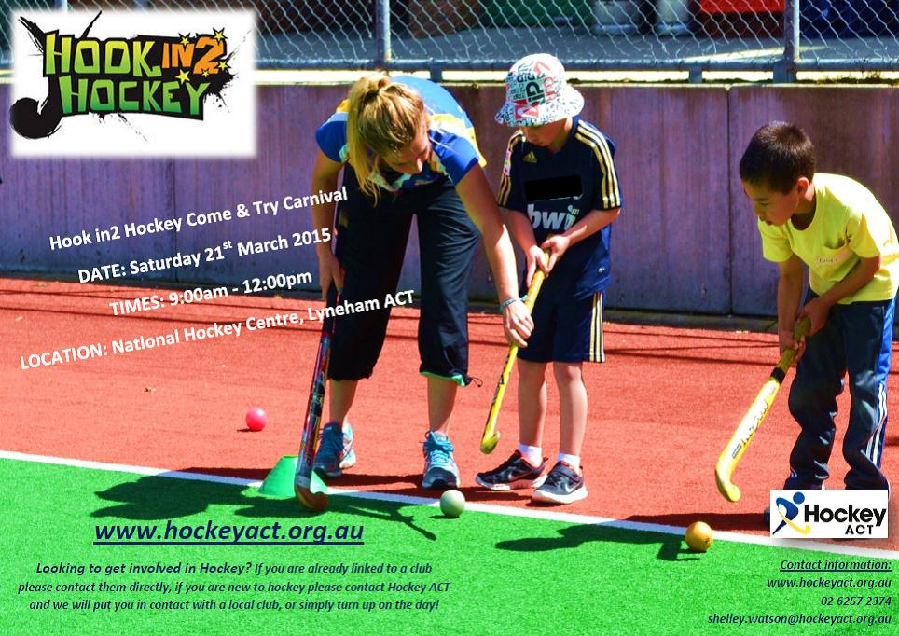**2 Free Lessons**

|  |
| --- |
| The school, its staff and the Territory are not aware of, and make no representation as to, the truth or accuracy of the information provided in advertisements appearing in this publication. Readers should make their own enquiries in relation to the information. |

**SCHOOL PSYCHOLOGIST**

[**The secret to raising confident kids**](http://parentingideas.com.au/Blog/August-2014/The-secret-to-raising-confident-kids) **Michael Grose**

The first habit from Stephen Covey’s wonderful book “The 7 habits of highly effective people” states that we should start every project or undertaking with the end in mind.  
This principle holds true for any activity whether it’s planting your vegie patch; renovating a house or raising children. When you know what you are trying to achieve then choosing the right strategies becomes easy.  
The end game or goal for parents is Redundancy. Yep, you read it right. Your job is to make yourself redundant as a parent from your child’s earliest possible age. It always has been and always should be.  
When redundancy is your aim most of your time, effort and energy will go into promoting independence. You’ll stop doing things for kids and start giving them opportunities to do things themselves. You’ll spend most of your active parenting time teaching, explaining and prodding your child toward independence.

**Independence leads to the 4 C’s**  
When independence becomes your priority then suddenly you’ve found a pathway to the development of other positive qualities and traits in your children including the key four - confidence, competence, creativity and character. Here’s how:  
**Confidence** comes from facing your fears and doing things for yourself.   
**Competence** comes from the opportunity to develop self-mastery that independence offers.  
**Creativity** is developed when kids solve problems themselves as opposed to someone solving them on their behalf, or worse, keeping kids safe. It’s amazing how resourceful kids can be when they are given the chance to resolve their own problems.  
**Character,**  which is essential for success, is forged under hardship and is needed if kids are to live a sturdy life. Kids need to be exposed to disappointment, failure and conflict if character strengths such as grit and perseverance are too be forged.

**Independence takes many forms**  
Adults are the gatekeepers for children’s independence. And of course, independence takes many guises.  
On a basic level it’s about developing children’s autonomy. Without realising it, many parents make choices on their children’s behalf. Kids build self-confidence when they do things for themselves, and make their own decisions.   
Independence is built when children spend time in unpredictable circumstances and environments such as the bush, and also have the opportunity to navigate their neighbourhoods on their own. There may be some risk involved but that is where the learning lay. *Eliminate the risk and you eliminate the learning.*  
Allowing kids to follow their own impulses even if they are different to their own parents is the key to gaining independence. This may mean that children choose healthy interests and pursuits that parents are unfamiliar with, or even swim against the tide of their parents’ wishes.  
Allowing kids to take responsibility and own their own problems builds confidence and competence. Start by expecting kids to help at home. Look for ways to develop self-help skills and don’t take their problems on as your problems.

**Manage visually**  
When your end game is redundancy and your priority is independence building then managing your kids in a visual  **Create junior versions of independence** It can be scary and also difficult developing independence in one big step way becomes your most obvious strategy. Management by mouth is a dependency strategy so talk less, use signs, lists and rosters backed up consequences to develop independence and responsibility in your children.

So smart parents intuitively develop junior versions of independence by breaking up big activities into digestible bits. Want your three year old to make the bed? Then start by arranging the teddies and the pillows (a junior version of making the bed) and let them work their way up from there. Similarly, want your five year old to walk to school yet it’s currently out of his skillset? Then accompany him most of the way and let him walk the last 200 metres to school on his own. That’s a junior version of walking to school.  
In all the noise and commotion about raising kids today it’s easy to forget that the job description for parents hasn’t changed since the dawn of time. Love them, bond with them, teach them and spend time with them. But also work like mad to develop their real independence so they become capable of handling what life will throw their way.   
Then you’ll know your job as a parent is ALMOST done! It doesn’t mean you won’t stop worrying about them……… that’s a story for another time. But it does mean you've finished the main task of parenting, that is, to make yourself redundant at the earliest possible age.

Amit Pearce (School Psychologist) (At Wanniassa Junior Campus Tuesdays and Thursdays)